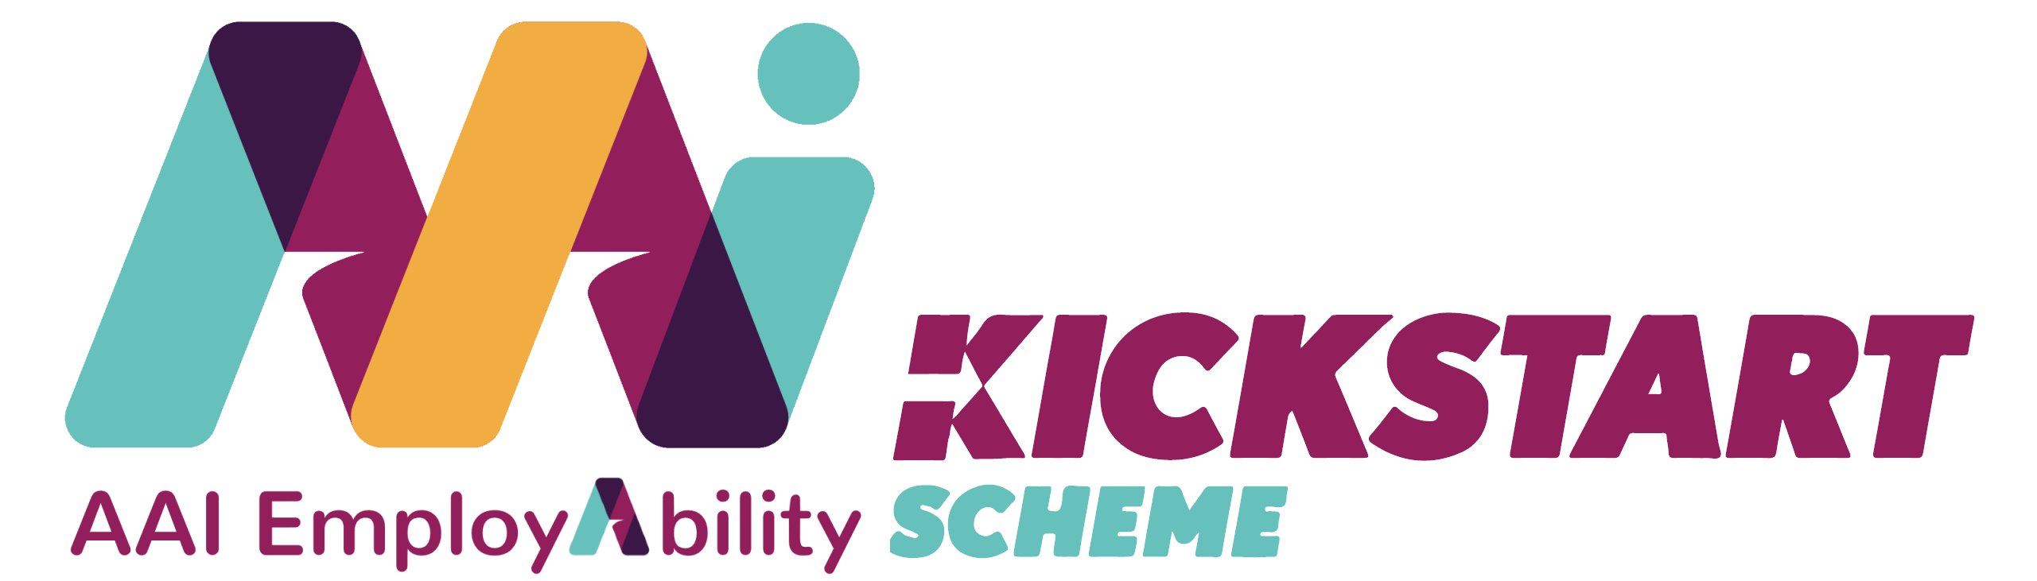

Transferable Workplace Competencies: Part 2

All employees require a basic set of transferable skills to succeed in the workplace and to successfully find new employment when necessary.

In this video AAI’s Jane Sloan and Nick Murray discussed:

- Respect and Boundaries
- Disputes and Conflict
- Basic Problem-Solving
- How to ‘Check Yourself’

In the box below, explain what resonated with you from the video under the questions provided. Was there anything in the video that surprised you? Do you feel more comfortable and confident understanding the importance of these topics?

What do you feel is the most important topic covered in the video for you and your placement?

Was there anything in the video that surprised you?

Do you feel more comfortable and confident understanding the importance of these topics?

